**Epidemiology Report on SARS-COV-2 Indiana, USA**

**Introduction**

COVID-19 (Coronavirus disease 2019) is a disease caused by a novel virus called SARSCoV-2 (severe acute respiratory syndrome coronavirus 2) which has spread over more than 200 countries infecting more than 40 lakh peoples worldwide (as on May 12,2020). The outbreak of this disease was announced by World Health Organization (WHO) after one month from the reporting of first case on Dec. 31, 2019, in Wuhan, China and later as a pandemic on March 11, 2020. Indiana is also in the thick of this highly infectious viral disease with over 40,000 people caught in its tentacles (as on June 19,2020).

The symptoms of COVID-19 range from mild to severe, which are indicated by mainly fever, cough, and respiratory distress. The two most important modes of transmission of corona virus are respiratory droplets and contact transmission (contaminated hands) with an incubation period 2-14 days. The virus spread rapidly around the world and several large-size clusters of the spread have been observed worldwide including outbreaks in China, USA, Spain, Russia, UK, Italy and India. Despite strong interventions including country wide lockdowns by governments of many countries, this pandemic is nowhere near full control in most of the countries except China and South Korea.

In the absence of a COVID 19 vaccine at the moment the only accepted way to attenuate the growth is to practice good hand hygiene, using masks compulsorily and social distancing. In a desperate race to stunt the spread of the coronavirus, millions of Americans have been asked to do what would have been unthinkable only a few months ago: Don’t go to work, don’t go to school, don’t leave the house at all, unless you have to prevent spreading of the virus from human-to-human transmission. Since these measures have brought huge pressure on economy, it is not only important to contain the spread of the Coronavirus but also to have quantitative estimates of the spread or its abetment to estimate its impact and to plan economic and health policies to reduce the shock on economy.

**SIR MODEL**

The **SIR Model** is one of the simplest compartmental models, and many models are derivatives of this basic form. The model consists of three compartments:

* **S** for the number of Susceptible
* **I** for the number of Infectious
* **R** for the number of Recovered or deceased (or immune) individuals.

In SIR model the idea works as follows I'm going to imagine taking all the people in the region say, Indiana (let it be **N)**, and dividing them into three different categories. The first category is called susceptibles. Susceptibles are all of the people that are capable of becoming sick from an infection. In this case, we'll assume we have some sort of infection that is capable of infecting everybody so at the beginning everybody is going to be susceptible then we have the second category of people those are the people who are infected and when you become infected you leave the susceptible category for most diseases after you've gotten it after you've been infected you're not now susceptible. Those who have the infected disease they are going to transition at some point hopefully into a recovered status and as long as I assume that the death rate is small compared to the number that are being recovered.

I can write this assumption as an equation by saying that the sum of the susceptibles (**S),** the infected **(I)**, and the recovered **(R)**, people adds up to **N.**

**Mathematical Model**

Rate of change of Susceptible Population $\frac{dS}{dt}$ = -βSI

Rate of change of Infectious Population $\frac{dI}{dt}$ = βSI-γI

Rate of change of Susceptible Population $\frac{dR}{dt}$ = γI

This model was implemented in python using SciPy for solving the differential equations. Key influencers here are the parameters β and γ: which are described as:

* β: Decides how much the disease can be transmitted due to exposure. An interesting point here is, this β can be different for a same kind of virus in different society. A society with less socialization will have a lower value of β.
* γ: is a parameter expressing how much the disease can be recovered in a specific period

**SIR MODEL OF INDIANA** (No Precautions Implemented)

Indiana is a USA state in the mid-western and Great Lakes region of North America. It is the 38 largest by the area and 17th most populous state of 50 United States and its capital and largest city in Indianapolis. It has a population of 6,732,219.

Let’s analyze the

N: - Total population

S(t): - Number of people susceptible on day t

I(t): - Number of people infected on day t

R(t): - Number of people recovered on day t

β: - Expected amount of people an infected person infects per day

D: - Number of days an infected person has and can spread the disease

γ: - The proportion of infected recovering per day (γ = 1/D)

N: 6,732,219 (Total Population)

γ: 0.0145 (Gamma)

β: Ro γ

I (0): 1

R (0): 0

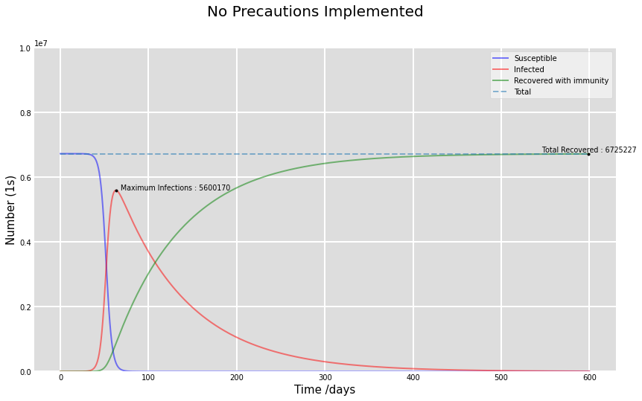

Initially, the entire population is susceptible to the infection, and very negligible amount of people bring this infection into the country. As the disease spreads, infectious section starts increasing, along with the number of recovered cases.

**Predictions in accordance with SIR Model (Actual observed values may be in vicinity**): -**

* Highest Number of Infected that may be Observed = 5,600,170 on 63th day from the start of Epidemic.
* Total Number of Recovered that may be Observed = 6,725,227 at the end of the Epidemic
* Duration of Epidemic = 6 days

**FITTING SIR Model**

To apply the model to an actual disease, we need to know the number removed per unit time, namely, $\frac{dR/}{dt}$ as a function of time. Using previous results, we can obtain an equation for R alone

which can only be solved in a parametric way. However, this form is not convenient. Of course, we can always compute the solution numerically if we know a, b, S0 and N0. But usually we don’t know all the parameters. Thus, we try to carry out a best fit procedure, assuming, of course, that the model actually is a reasonable description of the epidemic.

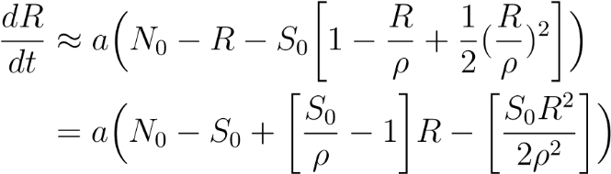Kermack and McKendrick argued that if the epidemic is not large, R/ρ is small. Using this observation, we can approximate equation (1) as

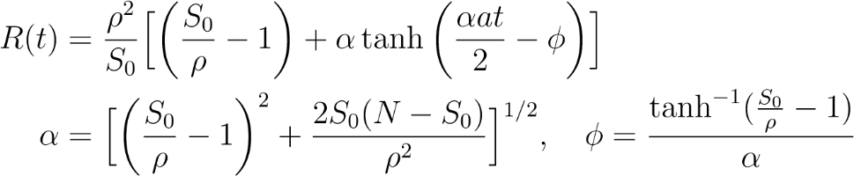Factoring the right-hand side quadratic in R, we can integrate the equation to get

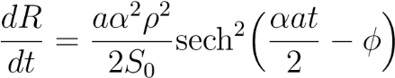The removal rate is then given by

which involves only three parameters, namely $\frac{aα2ρ2}{(2S0)}$, αb and φ. With epidemics that are not large, it is this function of time which we should fit to the Public Health records. On the other hand, if the disease is such that we know the actual number of the removed class, then it is R(t) that we should use. If $\frac{R}{ρ}$ is not small, however, we must use the original differential equation for $\frac{dR}{dt}$.

**Result And Analysis**